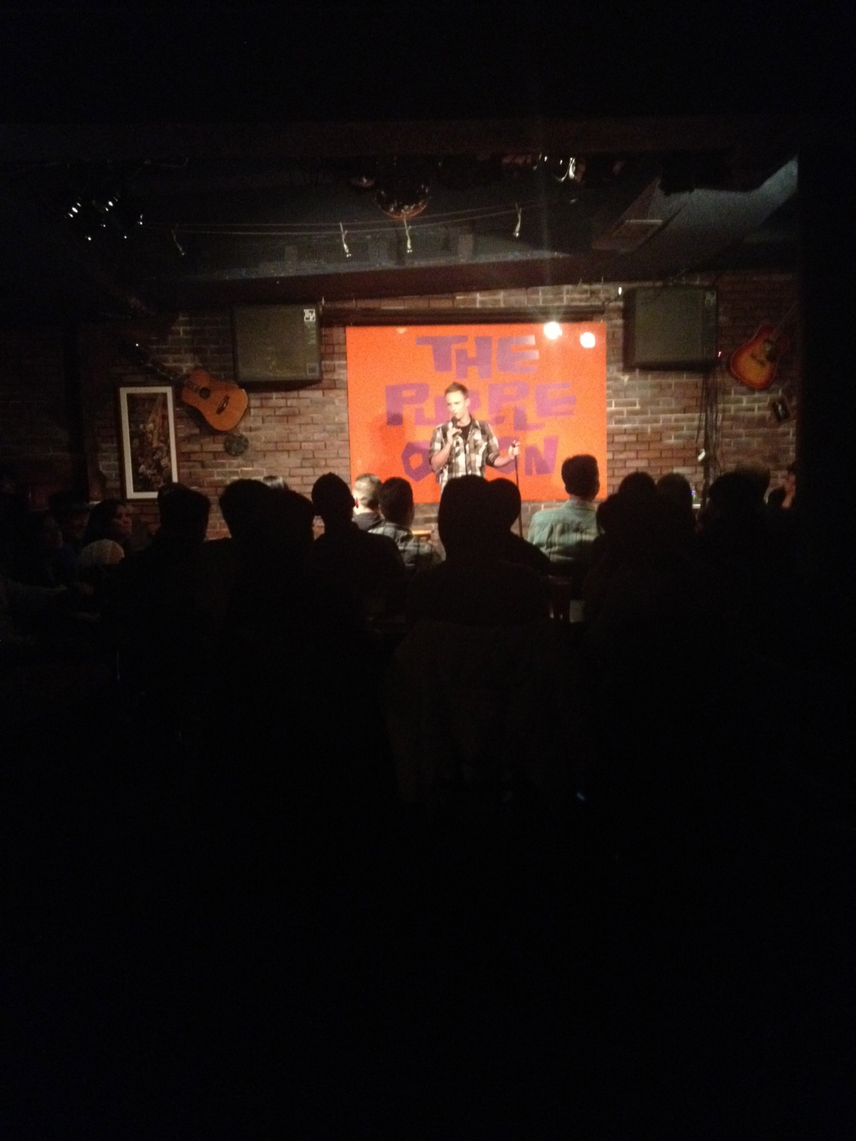
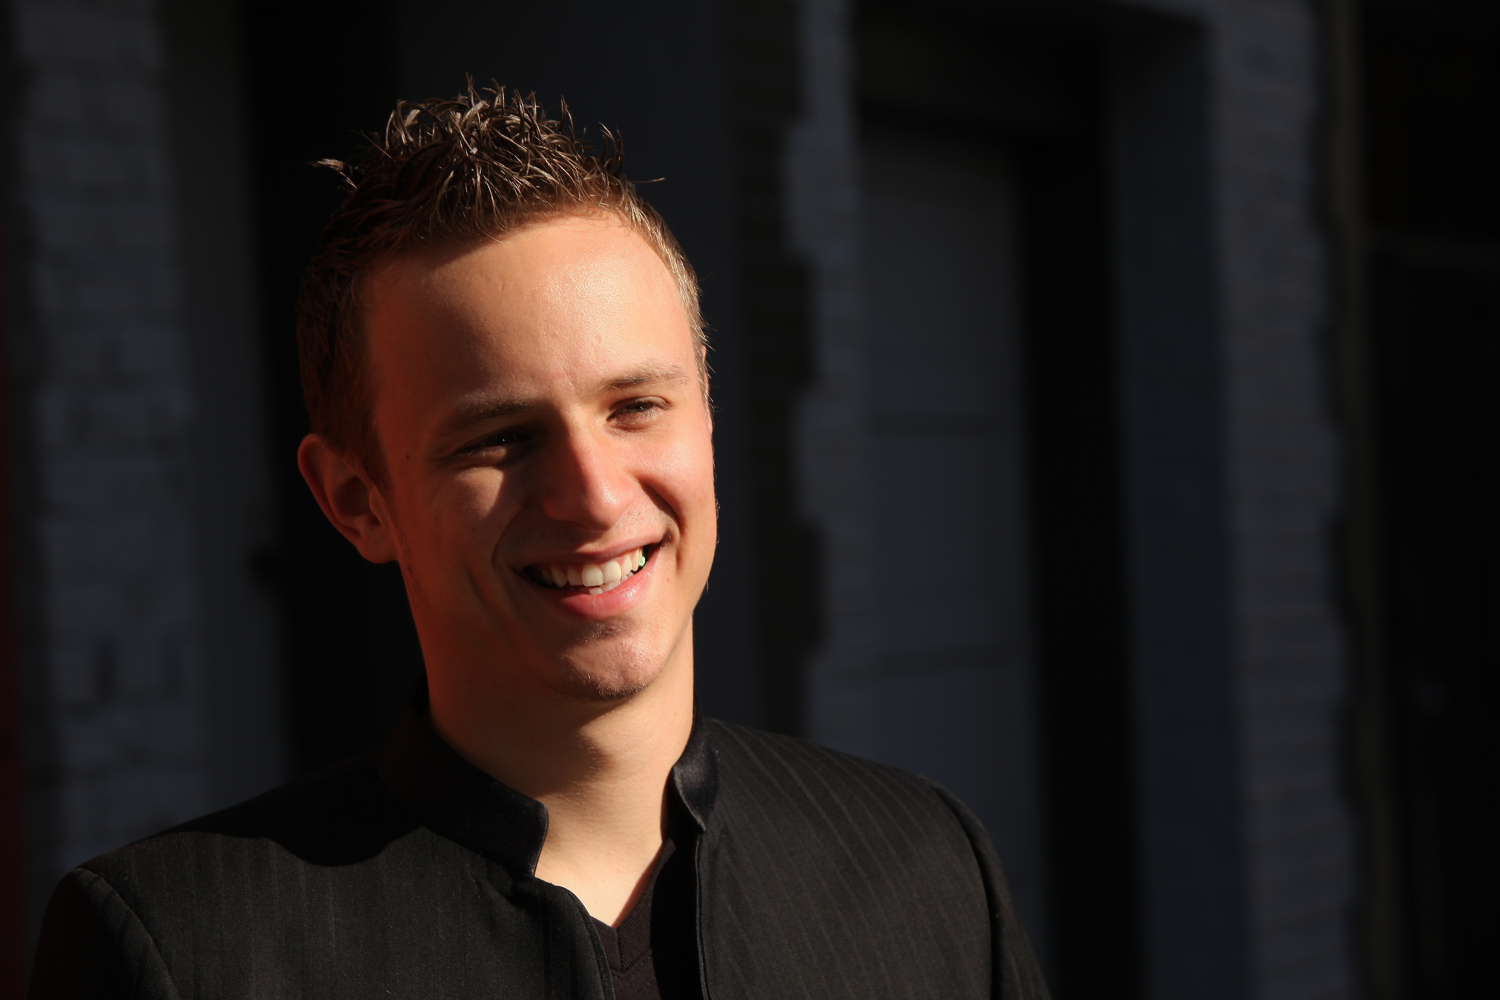
Cody Woods is one of the most hilarious and talented comedians rising today. While growing up idolizing comedians as a child he discovered he had a natural way of making everyone laugh early on. When he was thirteen, his math teacher recommended him to a local comedy club despite sending him to after school detention that day. With his unique versatility on stage audiences are treated to a rare blend of extreme honesty, off the cuff wit, social commentary, animation with spot on impressions all while maintaining a laid back narrative. Now a young yet seasoned comic Cody can be seen featuring and headlining comedy clubs all over California. He has regularly worked with big names such as Tommy Davidson, Charlie Murphy, Damon Wayans, Steve O., Robin Williams, , Bruce Bruce, Willie Barcena, , Tom Segura, Tom Rhodes, Tom Papa, Todd Glass, David Spade, Kevin Farley and many more. At his early stages he was already a two time finalist in the Northern California Comedy Competition held at the world famous Improv Comedy Club at the age of eighteen and nineteen. He was featured on Roger Ebert’s blog shortly after as well as the online streaming giant, hulu.com. Just recently he was hand picked for the Comedy Central’s Up Next Competition and was a finalist in the Shaq All-Star Comedy Competition.

Video Sample

For more updated videos click here

For more updated photos click here

Contact:
cody@codywoods.net
650-208-6490
Facebook: /CodyWoodsComedy

Headlined

Tommy T’s Comedy Club - Pleasanton CA & San Francisco
Improv Comedy Club - San Jose CA
Pepperbelly’s Comedy Club - Fairfield CA
Stanford University - Stanford CA
Punchline Comedy Club - San Francisco
St Stephens Green - Mountain View CA
Blue Lagoon - Santa Cruz CA
Club Deluxe - San Francisco CA
Eddie’s – Monterey CA
Our Little Theater -San Francisco CA
The Great Plate - Modesto CA
Palace Hookah Lounge - Hayward CA
Hotel Nikko - San Francisco CA
Claremont Hotel - Santa Clara CA
Fox Theater - Redwood City CA
Bobby D’s - Redwood City
Underground Pub - Redwood City
Dragon Theater - Redwood City
Station 55 - Gilroy CA
Skylounge - Fresno CA
Comedy Store Belly Room - Los Angeles CA

Many more available upon request

Featured

Ice House - Pasadena CA
Improv - Hollywood CA
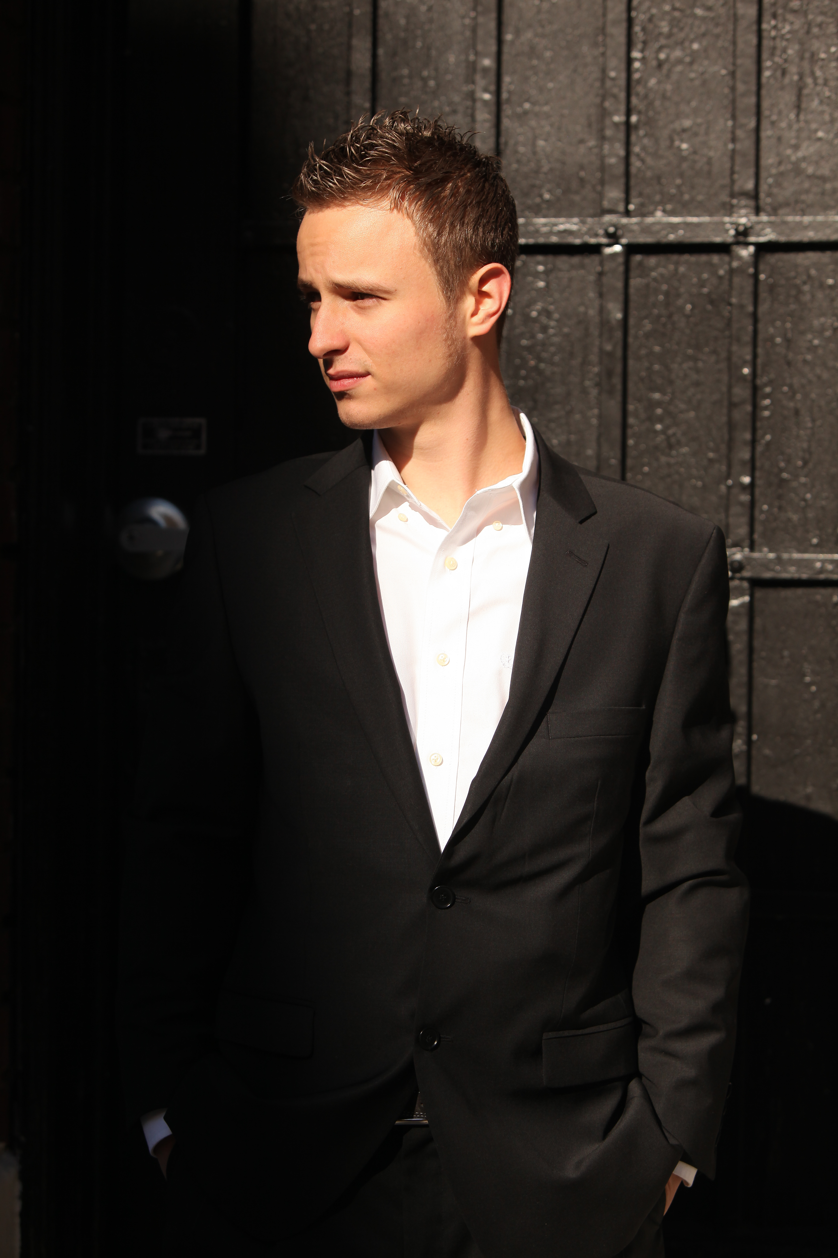
The Punchline Comedy Club - San Francisco, CA & Sacramento CA
Cobbs Comedy Club - San Francisco, CA
Improv Comedy Club - San Jose, CA
Tommy T’s Comedy Club - Pleasanton, CA, Rancho Cordova & San Francisco
Pepperbellys Comedy Club - Fairfield CA
Rooster T. Feathers Comedy Club - Sunnyvale, CA
Blue Lagoon - Santa Cruz,CA
Fat Cat - Modesto, CA
Eddie’s - Monterey, CA
City Beach - Fremont, CA
Foothill College - Los Altos, CA
CSU Sonoma - Sonoma, CA
Our Little Theater - San Francisco CA
Mushashi’s - Tracey, CA
The Verve Lounge - Aptos, CA
The Villa Roma - Redwood City CA
Fox Theater - Redwood City CA
Zelda’s - Capitola CA
Planet Gemini - Monterey CA
Brittania Arms - San Jose CA & Santa Cruz CA
Throckmorton Theater - Mill Valley CA
Bal Theater - San Leandro

Many more available upon request.

A list of some National Headliners Cody Woods has opened for:

Ali Wong (Feature) 2008
Bobby Slayton (Host) 2012 Twice (Feature) 2012 & 2014
Bobcat Goldthwait (Feature) 2012
Brent Weinbach (Host) 2008
Bruce Bruce (Feature) 2013
Capone (Host) 2013
Charlie Murphy (Host) 2013
Christopher Titus (Host) 2013
Coa Coa Brown (Feature) 2012
Damon Wayans (Host) 2013
Dat Phan (Host) 2014
Debbie Guiterrez (Host) 2013
DJ Cooch (Host) 2013
Donnell Rawlings (Host) 2014
Earthquake (Host) 2013
Esther Ku (Feature) 2010
Finesse Mitchell (Feature twice) 2013
Ian Edwards (Host) 2012
Iliza Shlesinger (Host) 2013
Kamau Bell (Feature) 2009
Kirk Fox (Host) 2013
Leslie Jones (Host) 2012
Lynn Koplitz (Feature) 2011
Moshe Kasher (Host) 2008
Michael Winslow (Feature) 2013
Pauly Shore (Host) 2014
Rex Navarrate (Host) 2013 & 2014
Ralph Harris (Host) 2012
Sebastian Cetina (Feature) 2011
Steve McGrew (Feature) 2012
Steve O. (Host) 2012
Todd Glass (Feature) 2013 & 2014
Tom Papa (Host) 2012
Tom Rhodes (Host) 2008
Tom Segura (Host) 2010
Tommy Davidson (Feature) 2013
Quinn Dahl (Host) 2013
Will Durst (Feature)
Willie Barcena (Host) 2012 (Host) 2013 (Feature

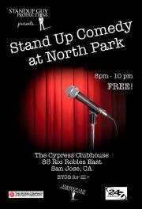
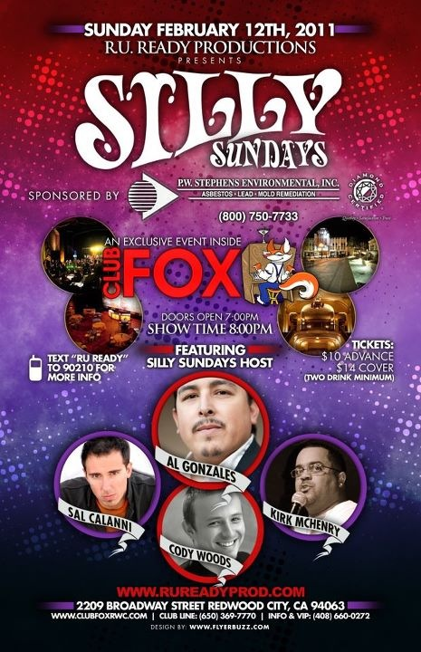
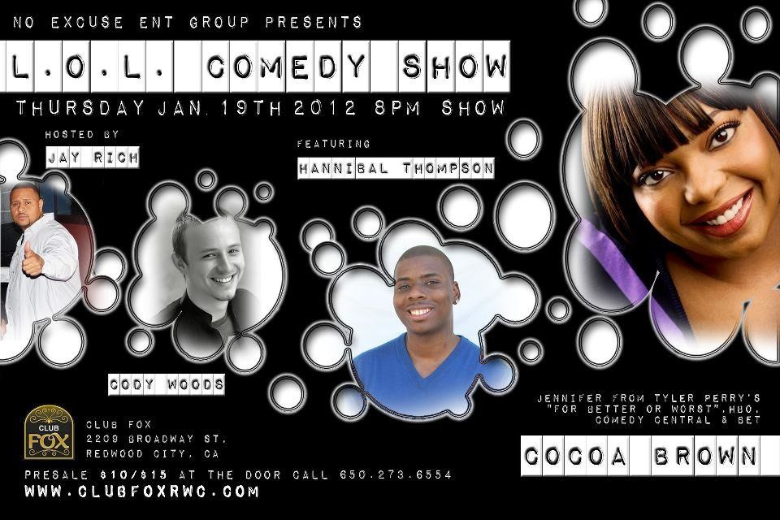
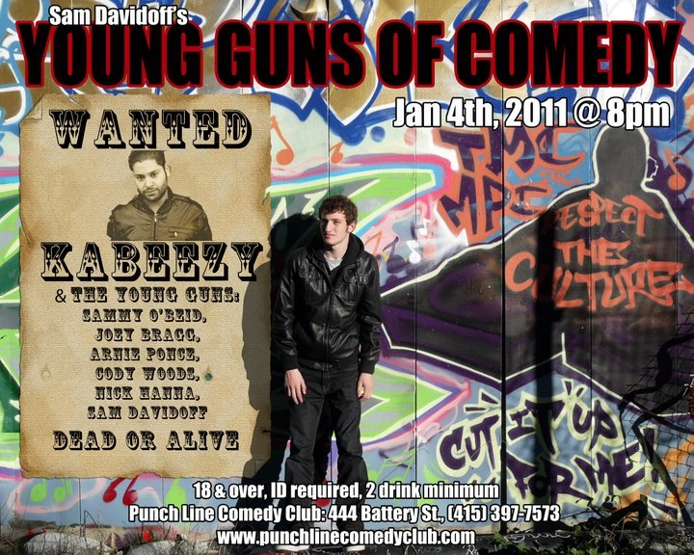
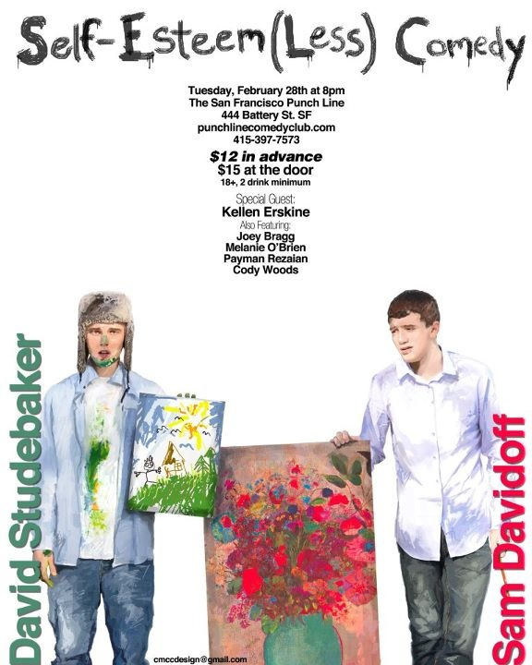
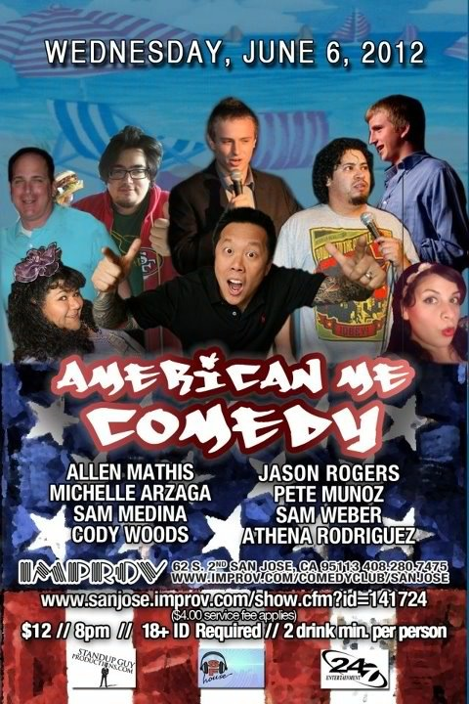
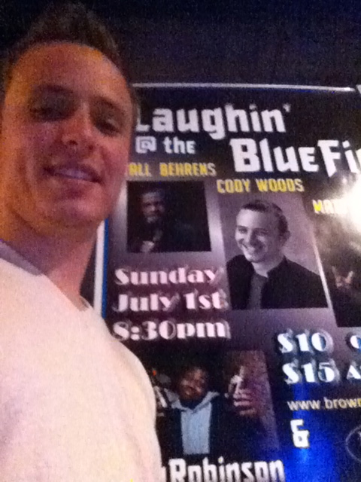
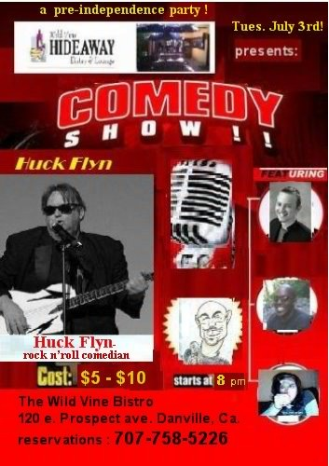
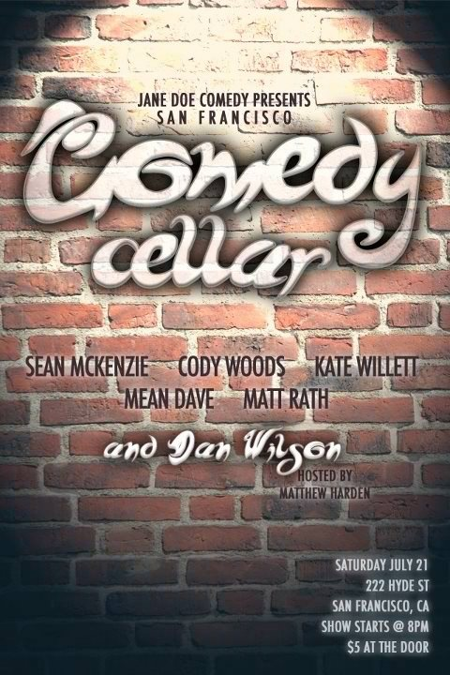
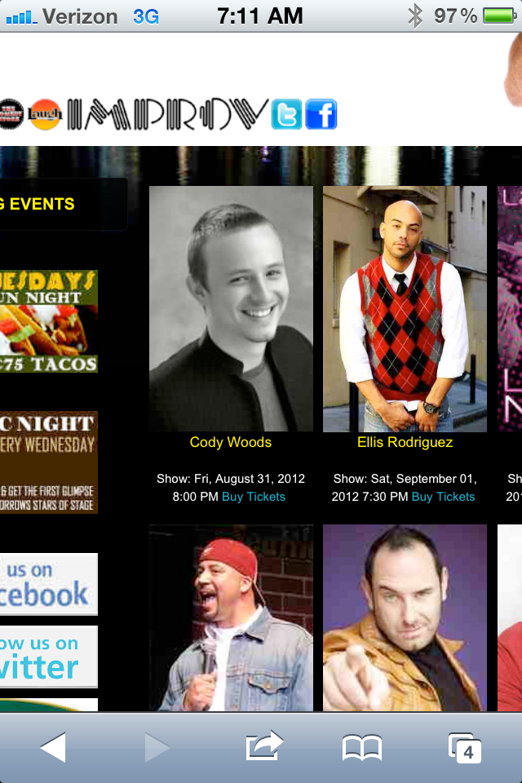
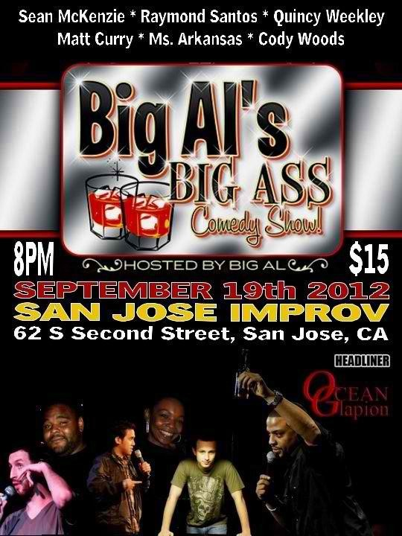
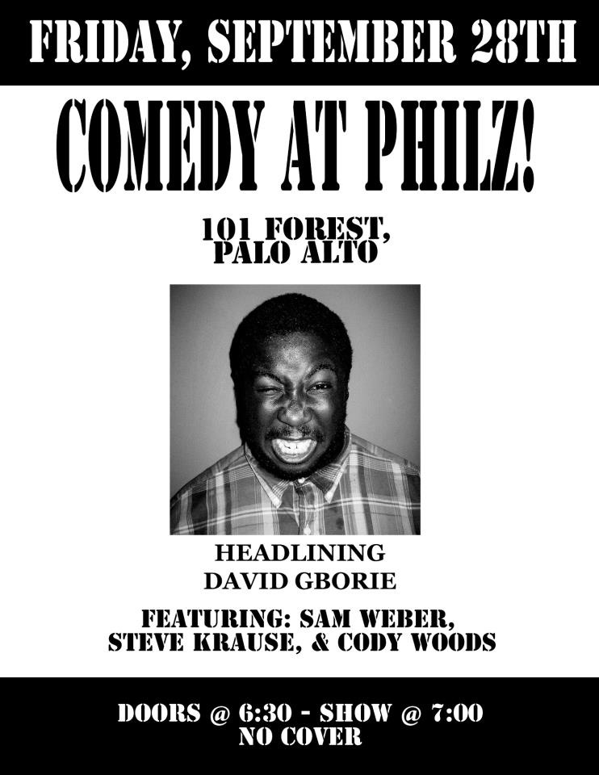
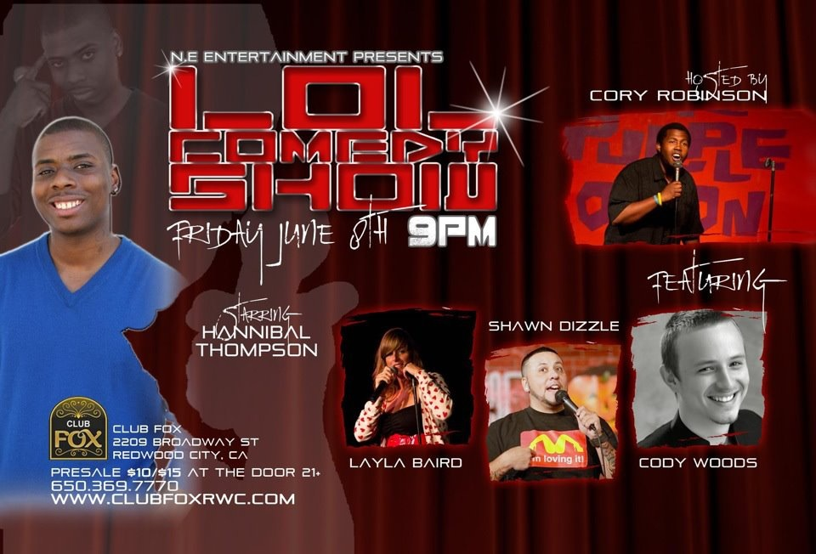
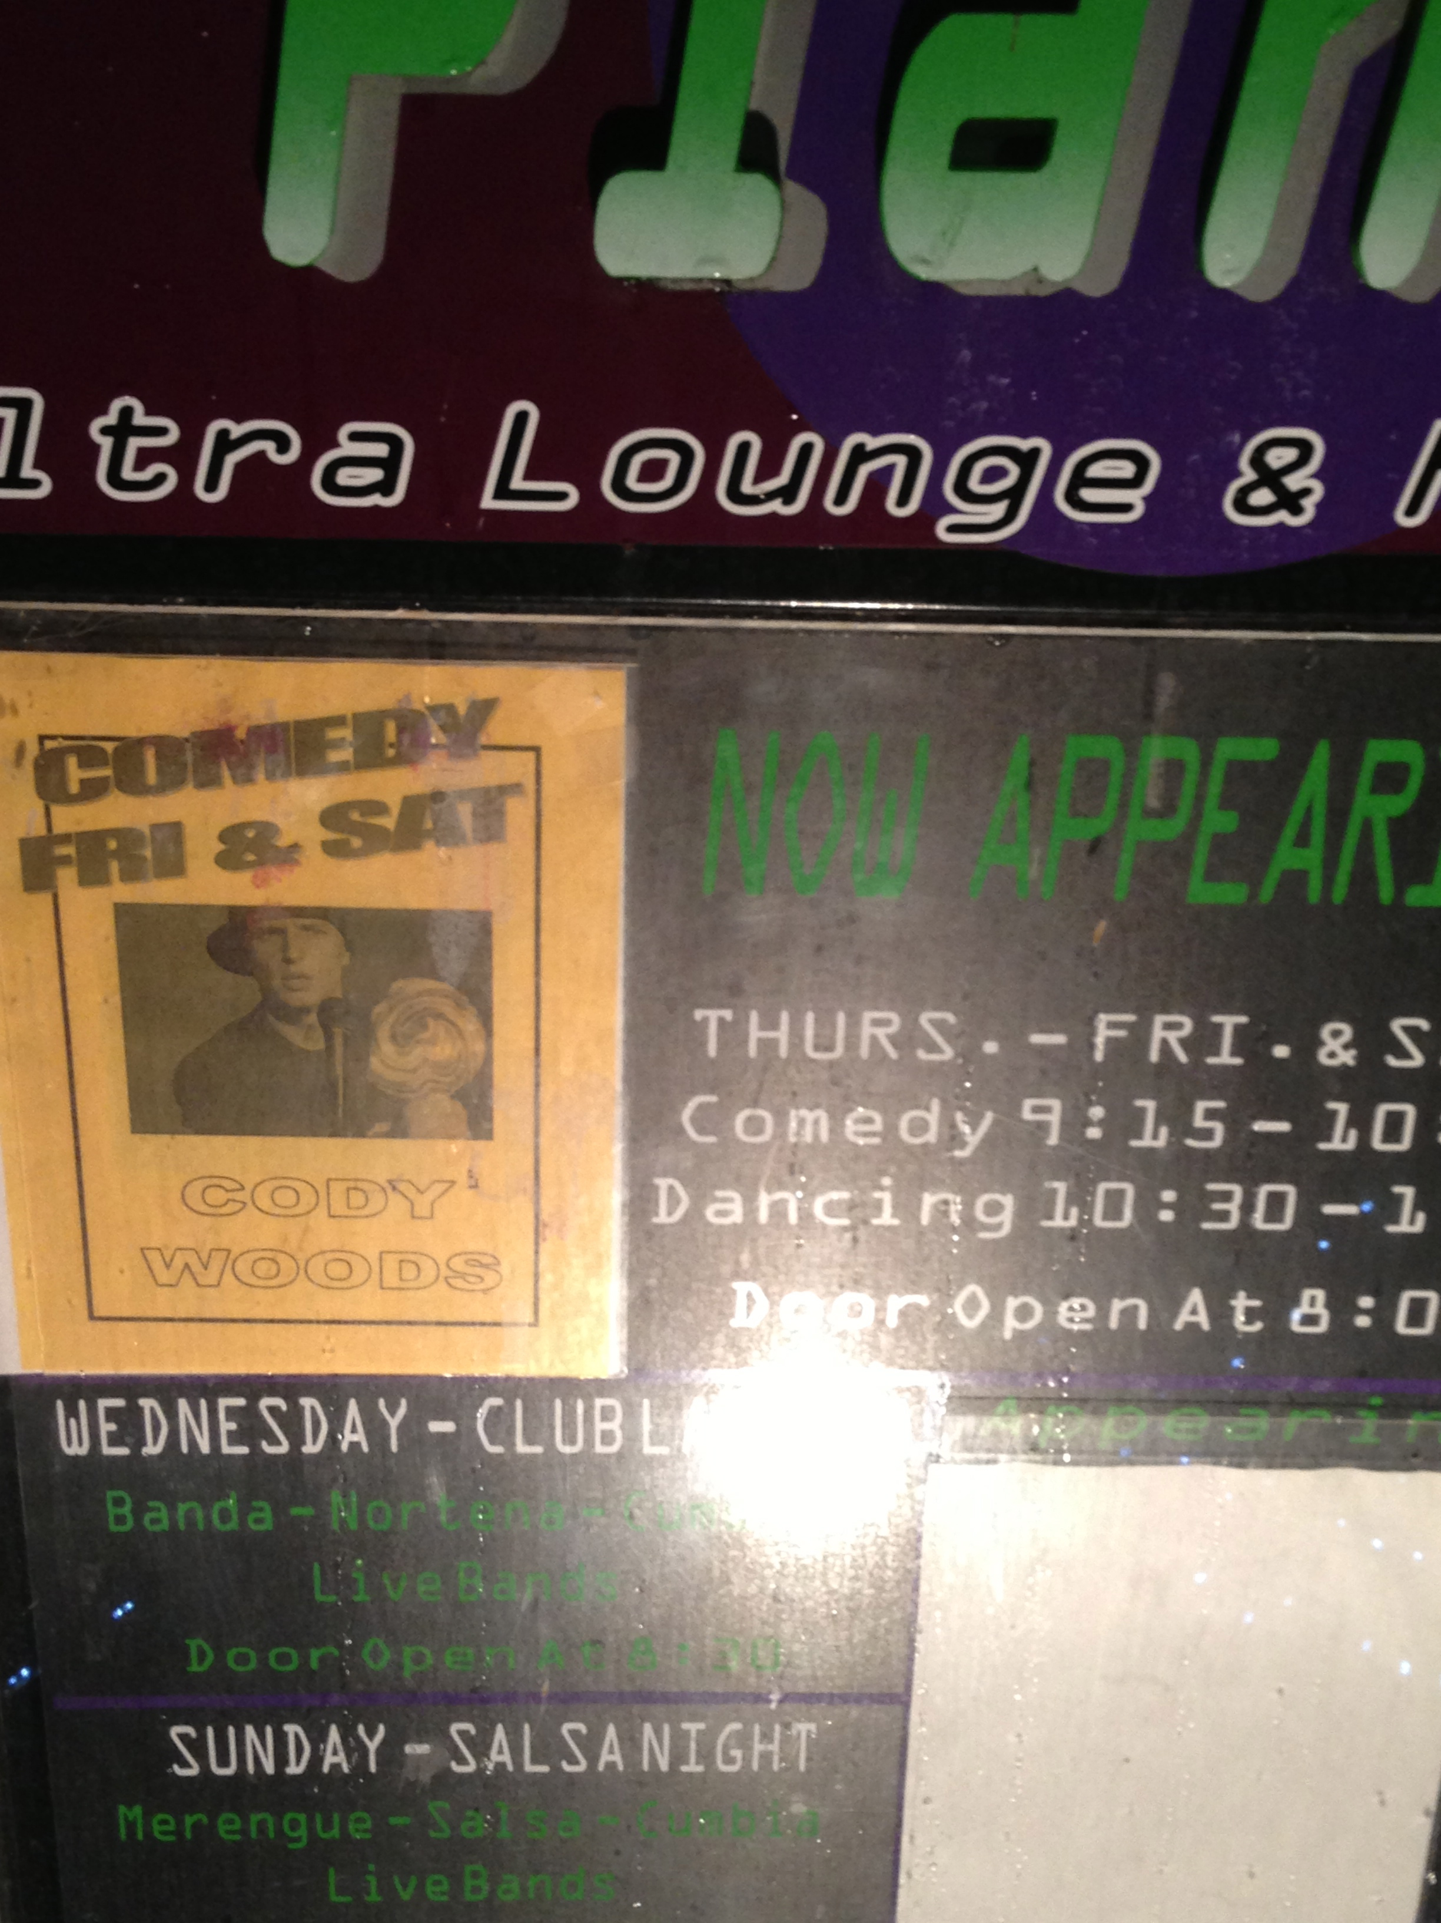
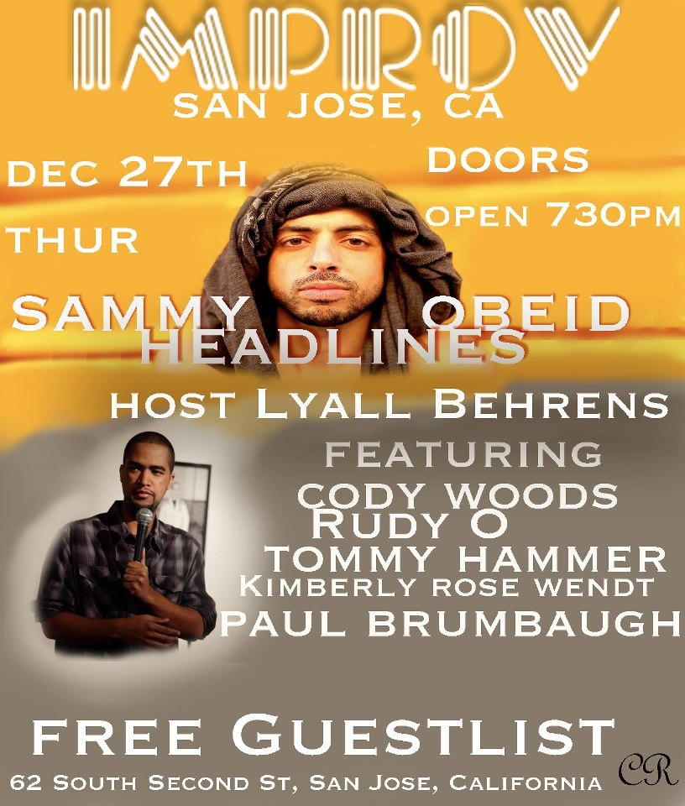
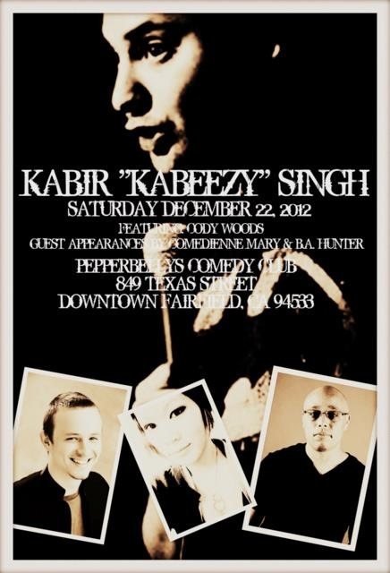
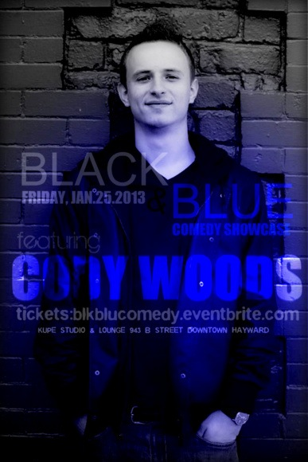
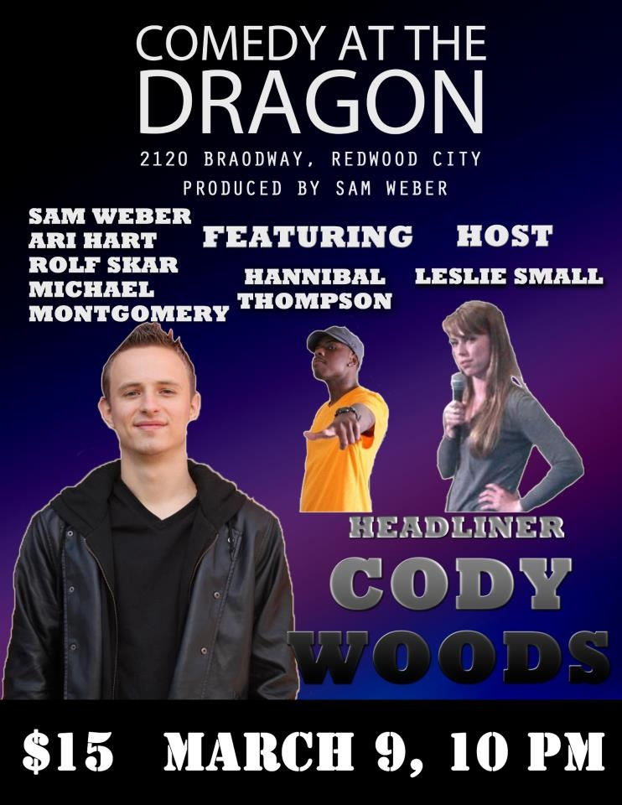
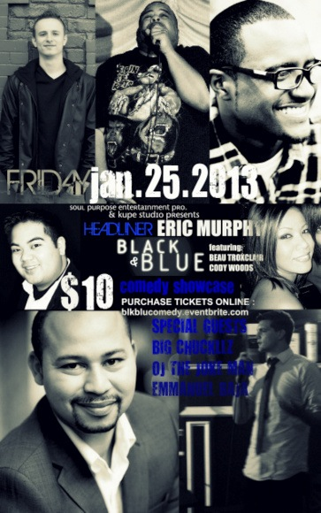
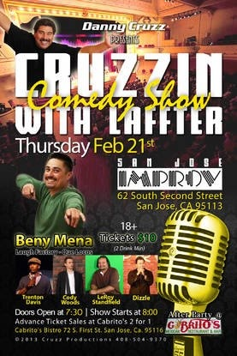
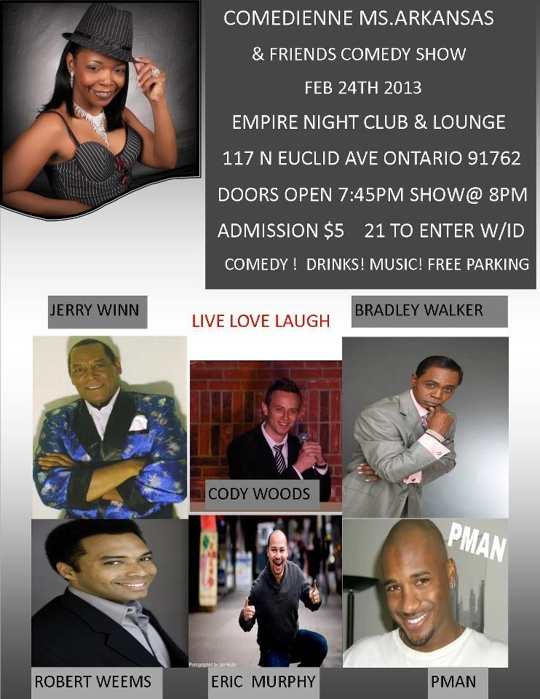
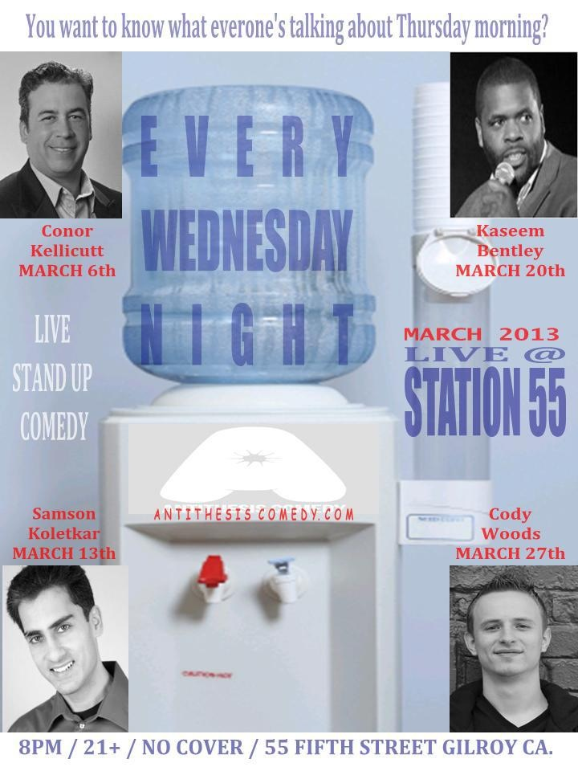
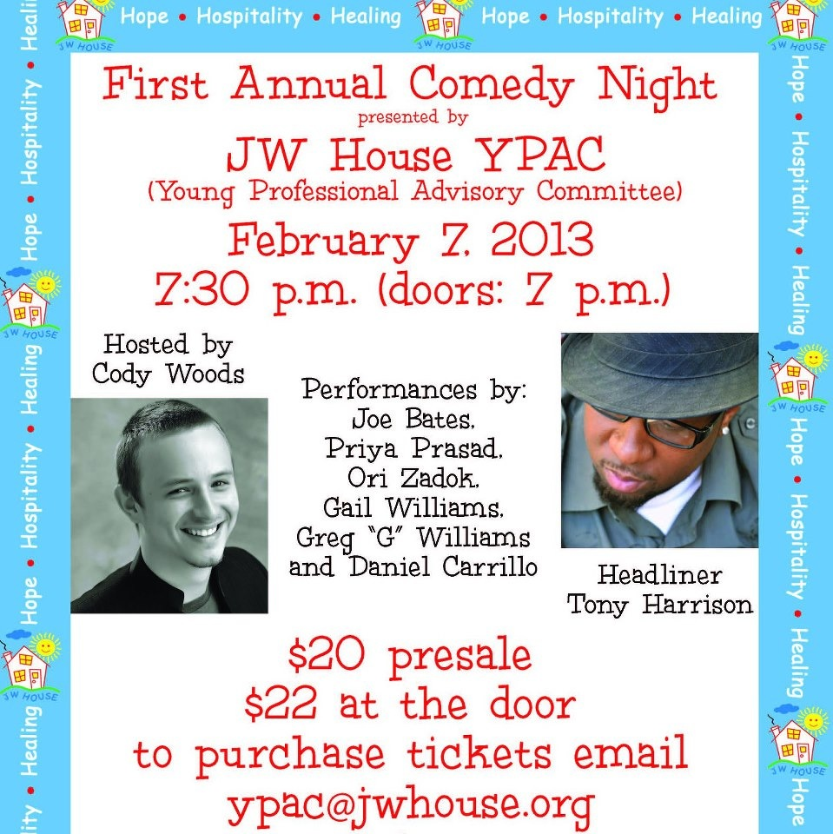
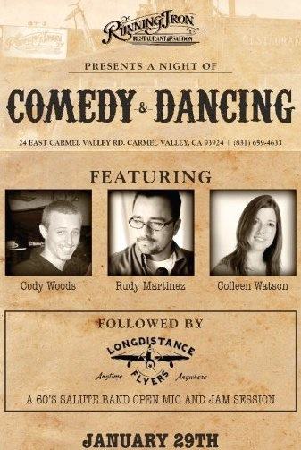
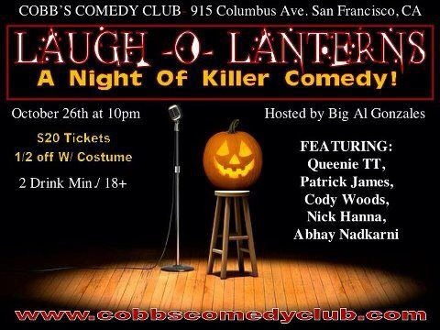
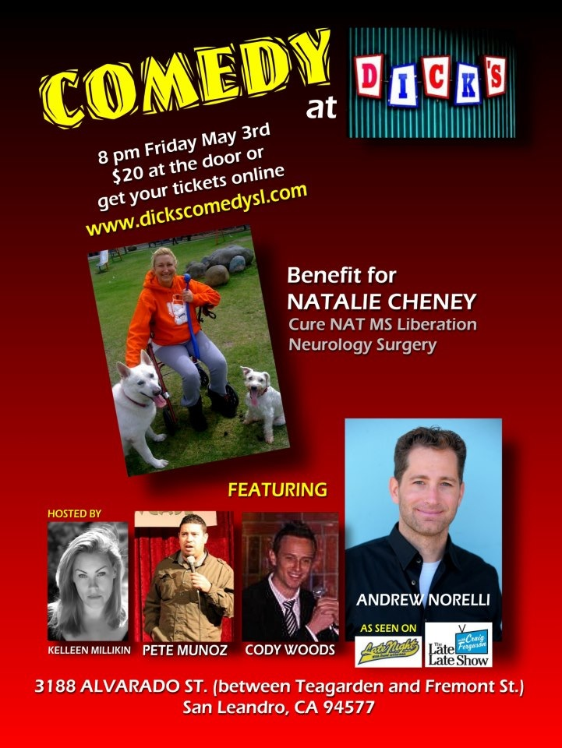
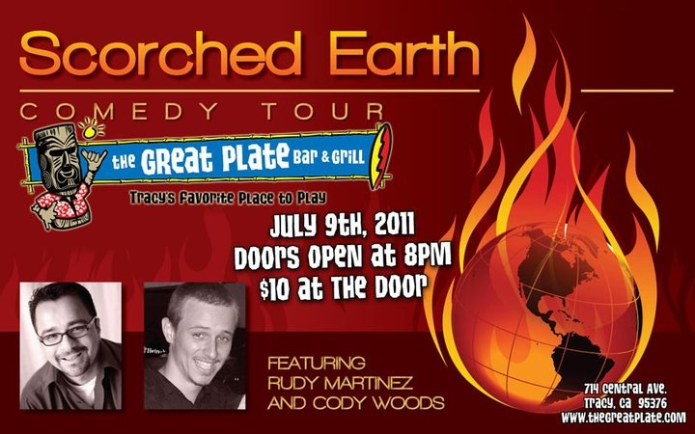
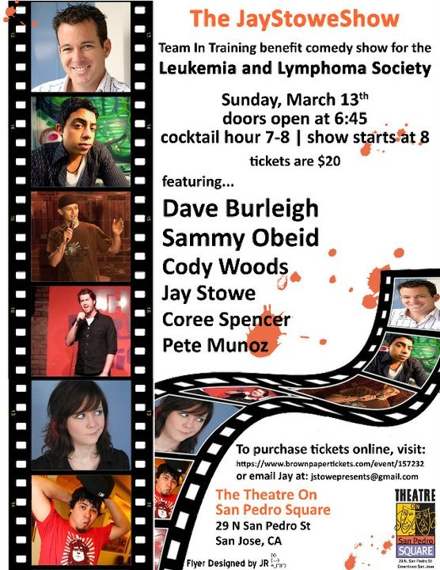
Willie Barcena (Host)

More available upon request

